Our VIRTUE for the month of DECEMBER is: PATIENCE
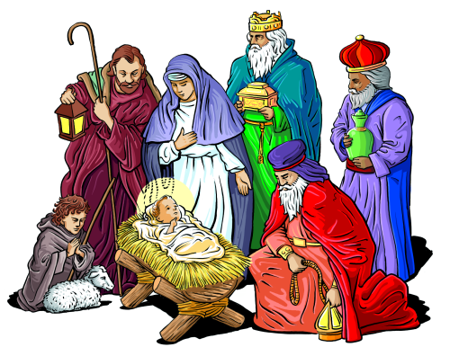DECEMBER 2020 NEWSLETTER
Our VIRTUE for the month of NOVEMBER was: JUSTICE (See award winners later in this newsletter)

FROM THE PRINCIPAL’S DESK:
SEASONS GREETINGS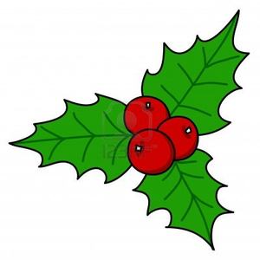

The season of Advent is a time to prepare for the birth of Jesus, our Saviour. Advent is a time to slow down, to enjoy time with friends and family, and to reflect on the true reason for the season. Traditionally the journey towards Christmas is marked by an Advent wreath. Advent wreaths are constructed of a circle of evergreen branches with 4 candles to represent the 4 weeks of Advent. Three candles are purple, and one is pink.

The purple candles symbolize prayer, penance, and preparatory sacrifices and good works which were undertaken at this time. The pink candle is lit on the third Sunday as we are getting closer to the joy of the birth of Jesus. We hope that you all have an opportunity to take time with your family to reflect on the true meaning of Christmas and to enjoy time together.

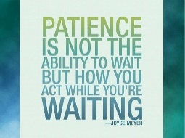
Also, during the month of December, our school will reflect on the Catholic character trait of PATIENCE. This is especially appropriate as we attempt to wait patiently for Jesus’ birth and the joys of the Christmas season.

Patience is a learned and valuable virtue. Ecclesiastes reminds that “for everything, there is a season, a time for every matter under heaven…”. As we wait for Jesus’ arrival, we take the time to develop patience. Through classroom activities, discussions, prayer and school liturgies, students will have the opportunity to explore and reflect on this virtue.

We wish you joy and peace during this Advent season. The staff and I would like to extend to you our heartfelt wishes to have a blessed, safe, relaxing, and enjoyable Christmas holiday.

Lucas Boluk

DECEMBER FUN DAYS
We will be having some extra fun at St. Peter during December with a few theme days. Every Friday, we add to the excitement as follows:
Friday, December 4 - Red, White and Green Day. Come dressed in the colours of Christmas.
Friday, December 11 – Ugly Christmas Sweater Day – if you don’t have an “ugly” Christmas sweater, you can borrow one, decorate a plain sweater for the day, or even wear a NICE one!
Friday, December 18 – PAJAMA DAY!!! Our last school day of the 2020 year will be a SUPER COMFY DAY!! Wear your favourite, most fun, and extra cozy pajamas.

MONTHLY AWARD WINNERS – NOVEMBER
We congratulate the following students on their academic success and/or demonstration of the virtue of JUSTICE throughout the month of NOVEMBER. Awards were presented to the students during our Month End Virtual Assembly on November 30.

ACADEMIC WINNERS |  | VIRTUE OF THE MONTH FOR NOVEMBER WINNERS  - JUSTICE
Teacher/Class | Student Winner | Teacher/Class | Student Winner
Ms. Dobrovodsky (JK/SK) | Sofia F. | Ms. Dobrovodsky (JK/SK) | Devyn R.
Miss DiSabatino (gr 1) | Chase F. | Miss DiSabatino (gr 1) | Arlo D.
Miss Csercsics (gr 2/3) | Jayden N. | Miss Csercsics (gr 2/3) | Brynlee R.
Mrs. McVey (gr 3) | Olivia W. | Mrs. McVey (gr 3) | Ainslie C.
Mr. Halsey (gr 4/5) | Clare F. | Mr. Halsey (gr 4/5) | Jesse D.
Mrs. Smith (gr 5/6) | Victoria S. | Mrs. Smith (gr 5/6) | Bella H.
Mrs. McBride (gr 7) | Elina C. | Mrs. McBride (gr 7) | Anthony I.
Mr. Enns (gr 8) | Nicolas A. | Mr. Enns (gr 8) | Lucas R.

CHRISTMAS DONATIONS ACCEPTED THROUGH SCHOOL CASH ONLINE
There are two School Cash Online opportunities for donations to the school community this year. Both are completely optional.
The first one was set up in response to requests from parents wanting to help reduce the costs to the school, and School Council, associated with providing FREE Christmas Turkey Luncheons to ALL our students. Families who would like to contribute specifically to this collection, may choose to donate $2, $5, or $10. All funds collected here, will be applied to the cost of food.
Our second donation opportunity has been linked to our THREE December Fun Days – Red, White and Green Day, Ugly Christmas Sweater Day, and Pajama Day. Suggested donation amounts, for your consideration, are $2 for each THEME DAY (or $6 total for all three). Families may also make LARGER donations, if they choose. Income Tax receipts can be issued for all donations of $20 or more, through the School Board. Monies collected through these donations will be used to support needy members of our school community to help make their Christmas a little brighter.
DONATIONS TOWARDS THE CHRISTMAS TURKEY LUNCHEON and THE DECEMBER FUN DAYS ARE COMPLETELY OPTIONAL. All interested students will participate in the meal and the fun days, regardless!

IMPORTANT INFORMATION ON OUR SCHOOL WEBSITE
If you have not already subscribed to receive notification of new postings on our school website, now is definitely the time to do so. The School Code of Conduct, the District Safe and Accepting Schools Plan and the School Safe and Accepting School Plan for this school year were posted in November and contain important information for ALL families.
Starting in December, we will be using School Messenger more frequently to update parents about events at the school and other things of importance. Families will be emailed newsletters, calendars and other things. If your email has changed, please update the school ASAP.

LUNCH DAYS AT ST. PETER SCHOOL
Wednesday, December 2 – Pizza Day Friday, December 4 – Pasta Day
Wednesday, December 9 – Pizza Day Friday, December 11 – Sub Day
Wednesday, December 16 – Pizza Day Friday, December 18 – Pita Day
** Thursday, December 17 – Turkey Luncheon – FREE – but MUST be ordered through School Cash Online so we have accurate numbers and there is no waste.

Please note that the 5-day window to ORDER lunches for JANUARY is Monday, December 28 through Friday January 1st. Don’t miss this order time which takes place DURING THE HOLIDAYS.
The dates for purchasing are as follows:
For January – December 21 through 25 CHANGED TO Dec. 28- Jan 1.
For February – January 25 through 29 For March – February 22 through 26
For April – March 22 through 26 For May – April 26 through 30
For June – May 24 through June 28
SchoolCash Online is the ONLY method of payment for Lunch Days. Contact the school if you need assistance setting up your account. Send any concerns/suggestions/inquiries to the school secretary (jdugas@bhncdsb.ca), using the Subject Line: SCHOOL LUNCHES. Thank you in advance.
Please note: there are NO refunds issued for days missed due to student absence. Missed lunches may be sent home with another designated student, be picked up by the parent, or remain in the school refrigerator until the following day (after that, for food safety reasons, the lunch will be discarded).
In the event of inclement weather that closes the school, lunch will be provided by the vendor on the NEXT school day.

INCLEMENT WEATHER – THINGS ARE DIFFERENT THIS YEAR!
If you have been a part of the BHNCDSB in previous years, you are already aware that transportation is occasionally cancelled and schools are closed due to bad weather and unsafe driving conditions. Notice of this cancellation can be found on the Board’s website, is announced on local radio stations and through School Messenger. Since COVID, these things remain the same, however, there is now a change.
Students in schools within a “closed zone/transportation cancelled” area on an inclement weather day (St. Peter School is in ZONE 4) will be provided with asynchronous learning opportunities through the D2L/ BrightSpace platform. Staff affected by any closure will be available throughout their regular workday to respond to any parent, student, or supervisor inquiries.
System staff have posted grade-appropriate literacy and numeracy activities, by division, to all Brightspace classrooms, both virtual and face-to-face, in the Content section. Instructions on how to access this material are available. Teachers may also wish to post their own material directly related to the subject curriculum.
This means that, in the event of inclement weather (aka a “snow day”), instruction will be provided online. Please be sure that your child is aware of this requirement and knows how to access the lessons for the day.

YOUR CHILD DAILY FOR SYMPTOMS OF COVID-19
On Oct 1st, the Ministry of Health changed the screening tool for students. If you have not already done so, please familiarize yourself with this new document, COVID-19 Screening Tool for Children in School and Child Care – Version 1 – October 1, 2020. All publicly funded schools and childcare centres in Ontario will reference this new screening tool.
The link to the online screening tool is: https://covid-19.ontario.ca/school-screening/

