Our VIRTUE for the month of JANUARY is: RESPONSIBILITY
JANUARY 2021 NEWSLETTER
Our VIRTUE for the month of DECEMBER was: PATIENCE (See award winners later in this newsletter)

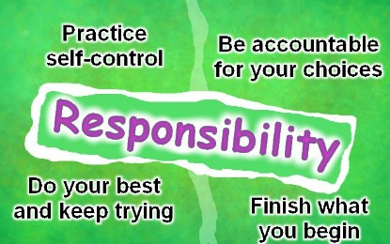

FROM THE PRINCIPAL’S DESK:

I wish to extend a very Happy New Year to everyone in our St. Peter School community. January is the month of new beginnings and fresh starts. Here at St. Peter School, we are focusing on the opportunity January brings to us all – a chance to renew our commitment to God, to others, and to ourselves. We
encourage our parents to take advantage of this opportunity to reflect with your children on how fortunate and blessed we are, and that we must strive to do our best with the talents and the blessings God has bestowed upon us. Please work with your children to set goals for themselves, both in their school work and in their social relationships, to achieve greater success this school year. 2021 is a promising year full of hope for health for all.
Lucas Boluk

OUR THEME DAYS WERE A BLAST IN DECEMBER!

On Friday, December 4th, the staff and student’s totally ROCKED Red, White and Green Day – showing off the BEST of our Christmas colours. Friday, December 11th was “Ugly Christmas Sweater Day”- and to paraphrase an old expression - “one person’s ugly Christmas sweater is another person’s treasured Christmas sweater.” Finally, Pajama day on the LAST day of school for 2020 was a cozy, relaxed and fun day with mini-Christmas parties in several of our classes. Many thanks to our Parent/School Council for their work in organizing our “Milk and Cookies” time on that day.

TURKEY LUNCHEON – December 17

Thanks to the staff of the Sherwood Restaurant for preparing a delicious, and SAFE, Christmas turkey luncheon for us. Thanks to our Parent Council for organizing and funding this event. Thanks also to the very many families who donated to offset the cost of the luncheon and made it possible for ALL students to participate!

RESULTS OF OUR “Here Come Christmas” Theme Days FUNDRAISER
Many thanks to our school community for their generosity in donating to our December fundraiser to support the less fortunate at Christmas time. Through SchoolCash Online, we collected $904.00!! As a result, several truly deserving members of our school community were able to have a better Christmas. God’s blessings to all. (Charitable donation income tax receipts will be mailed to those who donated $20 or more. These are issued by our School Board and take approximately 3 months for them to process.)

MONTHLY AWARD WINNERS – DECEMBER
We congratulate the following students on their academic success in writing and/or demonstration of the virtue of PATIENCE throughout the month of DECEMBER. Awards were presented to the students during our Month End Virtual Assembly on December 18.
Student winners receive an invitation from the principal to be treated to 2 slices of pizza in the following month. This month’s winners will receive their pizza treat on Monday, January 11, 2021.

ACADEMIC WINNERS  - WRITING |  | VIRTUE OF THE MONTH FOR DECEMBER WINNERS  - PATIENCE
Teacher/Class | Student Winner | Teacher/Class | Student Winner
Ms. Dobrovodsky (JK/SK) | Tatiana F. | Ms. Dobrovodsky (JK/SK) | Jackson M.
Miss DiSabatino (gr 1) | Emily H. | Miss DiSabatino (gr 1) | Aryella DK
Miss Csercsics (gr 2/3) | Virgil P. | Miss Csercsics (gr 2/3) | Ma’Laya C.
Mrs. McVey (gr 3) | Sonia C. | Mrs. McVey (gr 3) | Abby R.
Mr. Halsey (gr 4/5) | Ellie V. | Mr. Halsey (gr 4/5) | Avery R.
Mrs. Smith (gr 5/6) | Alex D. | Mrs. Smith (gr 5/6) | David R.
Mrs. McBride (gr 7) | Michaela S. | Mrs. McBride (gr 7) | Eden L.
Mr. Enns (gr 8) | Taylor N. | Mr. Enns (gr 8) | Kayley P.

LUNCH DAYS AT ST. PETER SCHOOL

The dates for purchasing are as follows:
For February – January 25 through 29 For March – February 22 through 26
For April – March 22 through 26 For May – April 26 through 30
For June – May 24 through June 28
SchoolCash Online is the ONLY method of payment for Lunch Days.
Please note: there are NO refunds issued for days missed due to student absence. Missed lunches may be sent home with another designated student, be picked up by the parent, or remain in the school refrigerator until the following day (after that, for food safety reasons, the lunch will be discarded).
In the event of inclement weather that closes the school, lunch will be provided by the vendor on the NEXT school day.

MOVEMENT BETWEEN VIRTUAL SCHOOL AND IN PERSON LEARNING

There has been a lot of movement in the past month with students returning from Virtual School to In Person learning at St. Peter. We welcome our students back. It is great to see you again. Some of our classes have all their virtual learners back while others still have a few who are doing well in Virtual School and have decided to continue. The next transition date to switch from Virtual School back to In Person learning is February 5, 2021. If you decide to switch between from Virtual to In Person or the other way, please notify both the virtual school (pvanleuven@bhncdsb.ca) and the school office at St. Peter (jdugas@bhncdsb.ca)

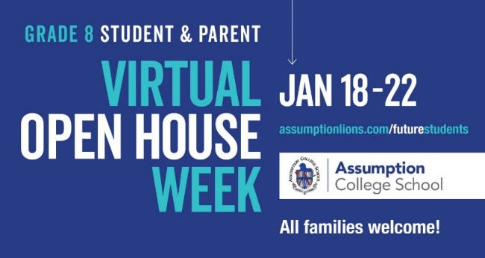

INCLEMENT WEATHER – THINGS ARE DIFFERENT THIS YEAR!
If you have been a part of the BHNCDSB in previous years, you are already aware that transportation is occasionally cancelled and schools are closed due to bad weather and unsafe driving conditions. Notice of this cancellation can be found on the Board’s website, is announced on local radio stations and through School Messenger. Since COVID, these things remain the same, however, there is now a change.
Students in schools within a “closed zone/transportation cancelled” area on an inclement weather day (St. Peter School is in ZONE 4) will be provided with asynchronous learning opportunities through the D2L/ BrightSpace platform. Staff affected by any closure will be available throughout their regular workday to respond to any parent, student, or supervisor inquiries.
System staff have posted grade-appropriate literacy and numeracy activities, by division, to all Brightspace classrooms, both virtual and face-to-face, in the Content section. Instructions on how to access this material are available. Teachers may also wish to post their own material directly related to the subject curriculum.
This means that, in the event of inclement weather (aka a “snow day”), instruction will be provided online. Please be sure that your child is aware of this requirement and knows how to access the lessons for the day.

CONCERNS: PLEASE ASSESS YOUR CHILD DAILY FOR SYMPTOMS OF COVID-19
On Oct 1st, the Ministry of Health changed the screening tool for students. If you have not already done so, please familiarize yourself with this new document, COVID-19 Screening Tool for Children in School and Child Care – Version 1 – October 1, 2020. All publicly funded schools and childcare centres in Ontario will reference this new screening tool.
The link to the online screening tool is: https://covid-19.ontario.ca/school-screening/

