Brant Haldimand Norfolk Catholic District School Board
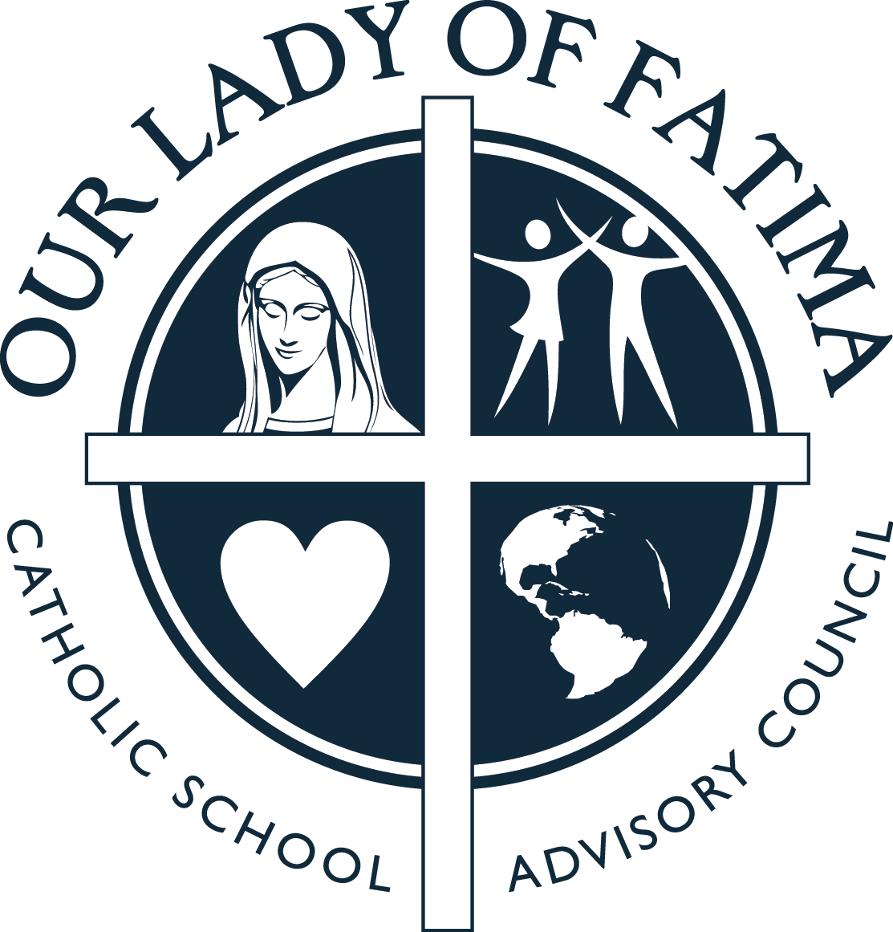
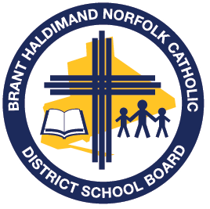
School Safe and Accepting Schools Plan 2020-21
St. Peters
Hearts on Fire (Luke 24:32) … Journey, Encounter, TRANSFORM
Priority Area | Goals | Key Activities | Indicators of progress
Promoting Gospel Values | - Our Catholic Learning Community here at, St. Peter will demonstrate our Gospel values which will include love, reconciliation, hospitality, justice, peace, honesty, and integrity. | Review recently revised BHNCDSB District Code of Conduct (as per revisions to PPM 128, Ontario Reg 440/20) with school staff, students, and parent community.  Active participation during school-wide virtual and classroom Liturgies and connections to daily scripture through Liturgies and/or as part of the Religious Education and Family Life curriculum.  Students and staff will participate in monthly classroom meetings and school-wide announcements, with a focus on our Board theme ‘TRANSFORM’. Principal and teachers will acknowledge student examples of actively living their faith as Joyful Disciples of Christ.  Our School will assist in raising money and/or resources for those in need within our school, our local and global community (while respecting Covid-19 restrictions). | Staff, parents, and students will be knowledgeable about the District and School Code of Conduct and respect/follow the expectations set out. It will be communicated to all members of the school community (e.g., School Website, Newsletter, Parent Council).  Students will have a deeper understanding of the Gospel message and how it can be connected to our lives today (e.g., through virtual Liturgies, Religious Education and Family Life classes, and acts of service).  Students will become more aware of the transforming presence of God in their lives and in the lives of others as they encounter one another.  Staff, students, and school families will become actively involved in supporting those in need throughout the school year (e.g. Supporting SSVDP, Christmas Collection, family in need) and proceeds will be donated as stated.
 | - Parents, students, staff, and appropriate community partners will work together to ensure St. Peter remains a safe place to learn. | Policies and procedures related to student behaviour, discipline and safety will be reviewed with staff, students, and parents.  Safe and Accepting Schools, Mental Health/Well-Being and Compassionate Care Response Team(s) will be formed at the school level, and may include, but is not limited to administration, teachers, staff, students, parents, and community partners. | Necessary Board Policies around Student Behaviour & Progressive Discipline (200.09) as well as Student Safety Plans and Notification of Risk of Injury (200.13) will be implemented and followed as needed at the school.  Established Safe and Accepting School, Mental Health/Well-Being and Compassionate Care Response Teams will assist with the development, implementation, and monitoring of Safe Schools Plans and will meet as necessary throughout the year.  Safe and Accepting Schools Plans submitted to Family of Schools Superintendent in the fall of each new school year.
 | - Continue the practice of Christian Meditation while also introducing new prayer experiences. | Continue the practice of Christian Meditation with all students (whole school, classroom practices) while also introducing new prayer experiences (as introduced and supported by the Board throughout the year). | There is visible evidence that school community (and classrooms) are participating on a regular basis in Christian Meditation and other prayer experiences.  Parents and students will share experience of Christian Meditation with school.
 | - Restorative Circles will continue to be used within classrooms to support and promote positive behaviours. | Build teacher capacity around the use of RESTORATIVE PRACTICES (while respecting Covid-19 restrictions) within the classrooms at St. Peter when/as needed. | Use of Restorative Practices in a more consistent manner within classrooms by teachers on a daily and/or weekly basis (e.g., circles/talks with groups of students as needed).
 | 5. Incorporate the principles of equity and inclusive education into all aspects of school policies, programs, procedures, and practices. | Ensure that principles of equity and inclusive education permeate School Improvement Plans.  Establish and maintain partnerships with all members of our diverse Catholic community so that the perspectives and experiences of all students are recognized, and their needs are met.  Examine and remove any barriers that exist that prevent successful access to the curriculum and full participation in the school community.  Communicate appropriate tenants of the BHNCDSB Equity and Inclusive Education policy to students, teachers, parents, and the entire Catholic school community. | Staff, parents, and students will be knowledgeable about the Board’s Equity and Inclusive Education Policy 200.23. The policy will be communicated to all members of the school community (e.g., School Website, Newsletter, Parent Council).  Students will have a deeper understanding of the congruence between Gospel values and our obligation to ensure equity in schools. Students will become more aware of the impact of discrimination on various groups.  Staff will continue to improve understanding and comfort regarding issues surrounding inclusive practices
Promoting Mental Health and Wellness | - To promote & utilize resources/materials to be sure ALL students feel welcome, accepted, and belong to the school community. | Utilize the board provided list of suggested resources/activities to help promote safe and caring classrooms that aligns with the Board’s Religious Education and Family Life Curriculum, Ontario Catholic School Graduate Expectations, Renewing the Promise: Pastoral Letter, and our current Board Theme.  Continue to utilize resources for reference in classrooms to promote safe, inclusive, and caring learning environments (i.e., Indigenous Education resources, Supporting Minds document, relevant educational books, Spec-Ed resources for schools such as sensory bins, reading materials).  Teachers will continue to be encouraged to utilize the Faith and Wellness resource. | Evidenced-based resources provided by the School Board through the Hub will be utilized St. Peter over the duration of the 2020-21 school year.  Appropriate resources and communication materials provided (and accessible on the Board website) will be utilized at St. Peter when/where possible.  Students will learn to care for their mental health and for the well-being of others through simple everyday classroom practices from the Faith and Wellness resource as implemented by school staff.
 | - Ensure access to mental health prevention and promotion programs are available and utilized at St. Peter when needed. | Evidenced-based classroom presentations (e.g., CYW, Health Unit) and school presentations where deemed necessary to support the general age group or needs of many of the students and/or families within that grade or classroom will be utilized as see fit at St. Peter (where possible given Covid-19 restrictions). | Conversations with students and families will indicate students feel better equipped to identify and support their mental health needs and access help if needed.  Decision Support Tool to be utilized when considering resources from outside the board.

Capacity Building | - Ensure potential high-risk behaviour of students is properly assessed and supported. | Support ongoing training (where possible given Covid-19 restrictions) for staff in the area of NVCI, SAFE TALK and ASIST Training on an as needed basis or by request (as available by the Board throughout the 2020-2021 school year). | Students who are having suicidal ideation and self-harm will be connected to help.  Principal and other trained staff will state an increased comfort and ability to support students/school in times of crisis.
 | - Continue to focus on and educate about the legalization of recreational cannabis as well as vaping and smoking (and long-term health effects). | Continue to educate and support staff in promoting safe and healthy school communities in relation to recreational cannabis, vaping and smoking during classroom lessons and teaching.  Use of Health Unit resources/discussions as part of our school collaborative Wellness Plan. | Talks will be age appropriate and relevant with the classroom and students will better understand the impact of early cannabis, vaping and smoking use and their long-term health effects.  There will be no evidence of use of cannabis, vaping and smoking on school property and at school sanctioned events.
 | - Training to address current and relevant safe school issues. | Continue professional learning and growth, including bullying recognition and response, will be accessible for all BHNCDSB employees. | Staff will acknowledge more understanding and comfort regarding issues surrounding safe schools. Consistent approaches and practices will be in place.
 | - As a school, we will participate in Bullying Awareness & Prevention Week during the week of Nov. 15 -21, 2020. | Daily prayers & reflections will take place as well as classrooms utilizing the Safe and Accepting Schools Bullying Awareness and Prevention Week 2020 Resource Package that was created and shared during the week of Nov. 15 -21, 2020.  School twitter feed will showcase the work we are engaging in as well as messages related to Bullying Awareness and Prevention Week. | Staff and students will acknowledge more understanding of what it means to live as joyful Disciples in a peaceful, inclusive, respectful community as well as a community of kindness. This new gained knowledge will be visible in daily interactions of students and staff within our school.  Continued compassion will be demonstrated by staff and students.
 | - Implement the practices that are within the revised Emergency Response Binder as required. | Revised Emergency Response Binder will be shared & reviewed with staff during 2020/2021 school year. | In the event of emergencies, the Emergency Binder material will be followed.  Revised Emergency Response Binder informs school practices and procedures.

Helpful Resources:

http://www.bhncdsb.ca/sites/content/files/resources/student_behaviour_discipline_safety_200.09_website_0.pdf

http://www.bhncdsb.ca/sites/content/files/resources/Equity_and_Inclusive_Education_200.23_combined_20160204.pdf

https://bhncdsbca.sharepoint.com/sites/BHNCommon/BHNOffice/Forms/AllItems.aspx?id=%2Fsites%2FBHNCommon%2FBHNOffice%2FGeneral%2FStudent%20Support%20Services%2FCompassionate%5FCare%5FResponse%5FGuidelines%5F20150127%2Epdf&parent=%2Fsites%2FBHNCommon%2FBHNOffice%2FGeneral%2FStudent%20Support%20Services

http://www.edu.gov.on.ca/eng/multi/english/BullyingEN.pdf

http://www.edu.gov.on.ca/eng/teachers/safeschools.html
http://www.edu.gov.on.ca/eng/healthyschools/educators-resources.html
http://www.prevnet.ca/sites/prevnet.ca/files/fact-sheet/PREVNet-SAMHSA-Factsheet-Bullying-Definitions.pdf
http://www.prevnet.ca/resources/tip-sheets

