Brant Haldimand Norfolk Catholic District School Board
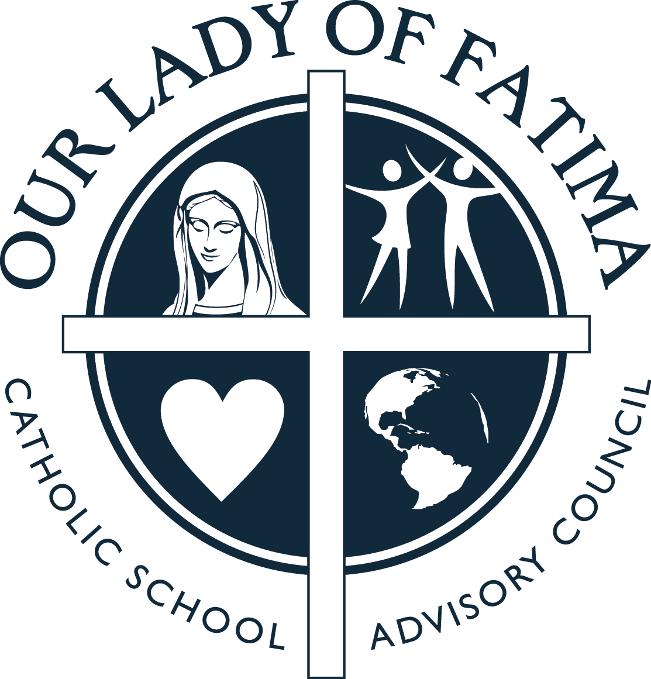
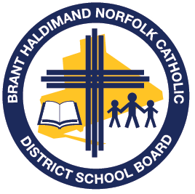
School Safe and Accepting Schools Plan 2020-21
St. Peter’s
Hearts of Fire (Luke 24:32)… Journey, ENCOUNTER, Transform
Priority Area | Goals | Key Activities | Indicators of progress
Promoting Gospel Values | - Our Catholic Learning Community here at, St. Peter’s will demonstrate our Gospel values which will include love, reconciliation, hospitality, justice, peace, honesty and integrity. | Review recently revised BHNCDSB District Code of Conduct (as per revisions to PPM 128) with school staff, students and parent community.  Active participation during school Masses/Liturgies and connections to daily scripture through Masses and/or as part of Religion curriculum.  Students and staff will participate in monthly assemblies with a focus on our Board theme ‘ENCOUNTER’. Principal and teachers will acknowledge student examples of positive Encounters witnessed.  Our School will assist in raising money and or resources for those in need within our school, our community and globally. | Staff, parents and students will be knowledgeable about the District and School Code of Conduct and respect/follow the expectations set out. It will be communicated to all members of the school community (e.g., School Website, Newsletter, Parent Council).  Students will have a deeper understanding of the Gospel message and how it can be connected to our lives today (e.g., through school Masses, liturgy of the word, Religion classes, Acts of Charity).  Students will become more aware of the impact and impression they leave behind throughout the ‘encounters’ they have with one another.  Staff, students and school families will become actively involved in supporting those in need throughout the school year (e.g. Operation Christmas, ‘Adopted family’) and proceeds will have been donated as designated.
 | - Parents, students, staff and appropriate community partners will work together to ensure St. Peter’s remains a safe place to learn. | Policies and procedures related to student behaviour, discipline and safety will be reviewed with staff, students and parents.  Safe and Accepting Schools, Mental Health/Well-Being and Compassionate Care Response Team(s) will be formed at the school level, and may include, but is not limited to administration, teachers, staff, students, parents and community partners.  Utilize the board provided list of suggested resources and activities to help promote safe and caring classrooms that aligns with the Board’s Religion Curriculum, Renewing the Promise: Pastoral Letter, and our current Board Theme.  Continue to utilize resources for reference in classrooms to promote safe, inclusive and caring learning environments (i.e., Indigenous Education resources, Supporting Minds document, relevant educational books, Spec-Ed resources for schools such as sensory bins, reading materials). | Necessary Board Policies around Student Behaviour & Progressive Discipline (200.09) as well as Student Safety Plans and Notification of Risk of Injury (200.13) will be implemented and followed as needed at the school.  Established Safe and Accepting School, Mental Health/Well-Being and Compassionate Care Response Teams will assist with the development, implementation and monitoring of Safe Schools Plans and will meet as necessary throughout the year.  Safe and Accepting Schools Plans submitted to Family of Schools Superintendent in the fall of each new school year.
 | - To promote & utilize resources/materials necessary to be sure ALL students feel accepted and part of the school community. | Utilize the board provided list of suggested resources/activities to help promote safe and caring classrooms that aligns with the Board’s Religion Curriculum, Renewing the Promise: Pastoral Letter, and our current Board Theme.  Continue to utilize resources for reference in classrooms to promote safe, inclusive and caring learning environments (i.e., Indigenous Education resources, Supporting Minds document, relevant educational books, Spec-Ed resources for schools such as sensory bins, reading materials). | Suggested resources/activities provided by the School Board will be utilized at St. Peter’s over the duration of the 2019-20 school year.  Appropriate resources and communication materials provided (and accessible on the Board website) will be utilized at St. Peter’s when/where possible.
Promoting Mental Health and Wellness | - Continue the practice of Christian Meditation while also introducing new prayer experiences. | Continue the practice of Christian Meditation with all students (whole school, classroom practices and home practices with primary families) while also introducing new prayer experiences (as introduced and supported by the Board throughout the year). | There is visible evidence that school community (and classrooms) are participating on a regular basis in Christian Meditation and other prayer experiences.  Parents of students and classrooms involved in Christian Meditation will share experience with school.
 | - Ensure access to mental health prevention and promotion programs are available and utilized at St. Peter’s for student well-being when/where needed. | Evidenced-based classroom presentations (e.g., CYW, Health Unit) and school presentations where deemed necessary to support the general age group or needs of many of the students and/or families within that grade or classroom will be utilized as see fit at St. Peter’s.  Build teacher capacity and begin to utilize the use of RESTORATIVE PRACTICES within the classrooms at St. Peter’s when/as needed. | Conversations with students and families will indicate students feel better equipped to identify and support their mental health needs and access help if needed.  Decision Support Tool to be utilized when considering resources from outside the board.  Use of Restorative Practices will be utilized in a more consistent manner within classrooms by teachers on a daily and/or weekly basis (e.g., weekly or daily circles/talks and circles/talks with groups of students as needed).

Capacity Building | - Ensure potential high-risk behaviour of students is properly assessed and supported. | Support ongoing training for staff in the area of NVCI, SAFE TALK and ASIST Training on an as needed basis or by request (as available by the Board throughout the 2019-2020 school year). | Students who are having suicidal ideation and self-harm will be connected to help.  Principal and other trained staff will state an increased comfort and ability to support students/school in times of crisis through discussions at staff meetings/Safe Schools meetings.
 | - Become better informed to the legalization of recreational cannabis as well as vaping and smoking concerns and long-term effects. | Continue to educate and support staff in promoting safe and healthy school communities in relation to recreational cannabis, vaping and smoking within classrooms.  Use of Health Unit resources/discussions as part of our school collaborative Wellness Plan. | Talks will be age appropriate and relevant with the classroom and students will better understand the impact of early cannabis, vaping and smoking use and their long-term effects.  Youth will be prevented from starting to use cannabis, vaping and smoking and there will be no evidence of use of cannabis, vaping and smoking on school property and at school sanctioned events.
 | - Online SAFESCHOOLS training for staff to address Safe Schools issues (bullying, abuse, harassment & discrimination) for staff. | SAFESCHOOLS online training, including bullying recognition and response will completed by school staff during the 2019-2020 school year as requested by the Board. | Staff at all levels will acknowledge more understanding and comfort regarding issues surrounding safe schools.  More consistent approaches and practices will be practiced.
 | - Implement the practices that are within the revised Emergency Response Binder as required. | Revised Emergency Response Binder will be shared & reviewed with staff for planned implementation during 2019-2020 school year. | In the event of emergencies, the Emergency Binder material will be followed.  Revised Emergency Response Binder informs school practices and procedures.

Helpful Resources:
https://bhncdsbca.sharepoint.com/Intranet/BHNOffice/School%20Office%20Management/Student%20Behaviour,%20Discipline,%20Safety%20(i.e.,%20Code%20of%20Conduct,%20Suspensions,%20Expulsions,%20Violent%20Incidents)/0%20-%20StudentBehaviour,Discipline&Safety_200.09_Policy&AP.pdf
https://bhncdsbca.sharepoint.com/Intranet/TeamSites/principals/Shared%20Documents/Compassionate%20Care%20Resources%20(Tragedy%20Response)/Compassionate_Care_Response_Guidelines_20150127.pdf
http://www.edu.gov.on.ca/eng/multi/english/BullyingEN.pdf
https://edu.gov.on.ca/eng/safeschools/respect.html
http://www.edu.gov.on.ca/eng/healthyschools/educators-resources.html
http://www.prevnet.ca/sites/prevnet.ca/files/fact-sheet/PREVNet-SAMHSA-Factsheet-Bullying-Definitions.pdf
http://www.prevnet.ca/resources/tip-sheets

